

Student Names: Kamogelo Motau
Student Number: ST10500865
Module Code: PDAN8411
Description: Part 3 - POE
Date: 22 June 2026
Table of contents

1. Analysis Plan & Justification 2
1.1. Model Justification 2
1.2. Dataset Suitability and Quality 3
1.3. Analysis Pipeline 3
2. Exploratory Data Analysis (EDA) 4
2.1. Data Overview & Cleaning 4
2.2. Rating Distribution 5
2.3. Reviews by Medical Aid 6
2.4. Review Length Analysis 6
3. Feature Engineering & Selection 7
3.1. Creating Sentiment Labels 7
3.2. Text Preprocessing 7
3.3. Feature Extraction (TF-IDF) 7
4. Model Training & Hyperparameters 8
4.1. Sentiment Analysis Model (Logistic Regression) 8
4.2. Topic Modeling Model (LDA) 8
5. Model Evaluation & Interpretation 8
5.1. Sentiment Analysis Evaluation 8
5.2. Important Predictive Words 10
5.3. Topic Modelling Findings 10
6. Retraining & Improvement Strategy 11
7. Business Recommendations 11

Analysis Plan & Justification
This section outlines the strategic decisions made for this analysis, ensuring alignment with the client's business objectives.

Model Justification
To meet the client's needs of identifying broad areas of concern and analyzing customer sentiment, a combination of two core text analysis techniques was chosen:
- Unsupervised Learning (Topic Modelling): To discover the main themes or topics in the reviews without prior labeling.
  - Model: Latent Dirichlet Allocation (LDA).
  - Justification: LDA is a widely-used, probabilistic model for discovering abstract topics within a corpus of text. It is ideal for identifying the underlying "areas of concern" in an unsupervised manner, providing a thematic overview of the customer feedback.
- Supervised Learning (Sentiment Classification): To automatically categorize the sentiment (Positive, Neutral, Negative) of each review.
  - Model: Logistic Regression.
  - Justification: Logistic Regression was selected because it is an excellent, robust baseline model for text classification. It is computationally efficient, easily interpretable (allowing us to see which words most influence sentiment), and performs exceptionally well on high-dimensional sparse data like TF-IDF (Term Frequency-Inverse Document Frequency) vectors.

Dataset Suitability and Quality
- Dataset: reviews.csv (Hello Peter Medical Aid Reviews).
- Records: 4,965 reviews.
- Relevance: The dataset is highly suitable as it is a direct source of unsolicited customer feedback, which is the exact data required to understand both sentiment and underlying concerns.
- Quality:
  - Completeness: The key textual columns (review_content, review_title, business_name) are nearly complete, with only 2 null values in review_title which were handled.
  - Richness: The combination of text content and a numerical rating provides a strong foundation for both unsupervised (LDA) and supervised (Sentiment) modeling.
  - Sufficiency: With nearly 5,000 records, the dataset is large enough to train a reliable supervised classification model and to find stable, meaningful topics using LDA.

Analysis Pipeline
The analysis was conducted in the following planned, sequential steps:
- Exploratory Data Analysis (EDA):
  - Goal: Understand the dataset's structure, identify missing values, and explore the distribution of key variables (review_rating, business_name).
- Data Preparation & Feature Engineering:
  - Goal: Clean the text data to make it suitable for modeling and create a new feature for supervised learning.
  - Steps: Combine review_title and review_content into a single text field; perform text cleaning (lowercasing, removing special characters and extra spaces); create sentiment labels from review_rating.
- Feature Selection & Extraction:
  - Goal: Convert text data into numerical features that algorithms can understand.
  - Method: Use TF-IDF Vectorization with a maximum of 5,000 features and ngram_range=(1,2) to capture both single words and important bigrams (e.g., "customer service"). For topic modeling, a Count Vectorizer was used.
- Model Training:
  - Goal: Train the selected models (LDA and Logistic Regression).
  - Method:
    - Logistic Regression: Train using sklearn with a class_weight='balanced' parameter to handle the imbalanced nature of sentiment data.
    - LDA: Fit the model to the CountVectorizer output to extract 5 distinct topics.
- Model Evaluation & Interpretation:
  - Goal: Assess model performance and interpret the findings.
  - Metrics: Accuracy, Classification Report (Precision, Recall, F1-Score), Confusion Matrix for the Logistic Regression. For LDA, interpret the top words for each topic.
- Reporting:
  - Goal: Synthesize the analysis into a clear, visual report for the client with actionable recommendations.

Exploratory Data Analysis (EDA)
This section details the initial data investigation to ensure a solid foundation for modeling.

Data Overview & Cleaning
- Initial Shape: The dataset contained 4,965 records and 27 columns.
- Relevant Columns: The analysis focused on review_title, review_content, review_rating, business_name, and created_at.
- Missing Values:
  - review_title: 2 missing values.
  - All other selected columns had 0 missing values.
- Duplicates: No duplicate rows were found, but a check was performed and no action was required.

Rating Distribution
A bar chart of the distribution of review ratings reveals a significant insight:
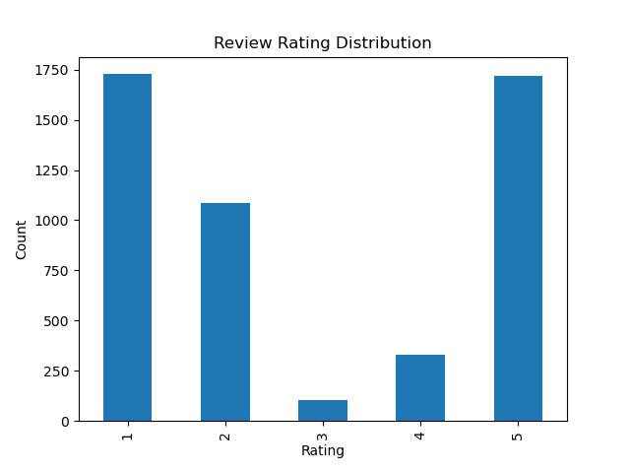
Figure 1: Review Rating Distribution

- Observation: The dataset is heavily skewed towards negative reviews. Ratings of '1' are overwhelmingly the most common.
- Interpretation: This indicates that customers are more likely to leave a review when they have a negative experience, a common phenomenon in online reviews. This was a crucial observation for sentiment modeling, as it meant our sentiment labels would be imbalanced.

Reviews by Medical Aid
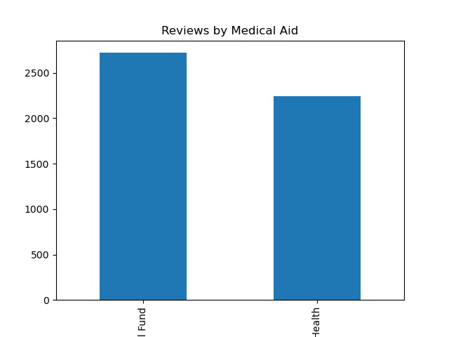
Figure 2: Reviews by Medical Aid

- Observation: The dataset contains significantly more reviews for Affinity Health (4,302) than for Bonitas Medical Fund (663).
- Interpretation: This distribution should be considered when interpreting the final results, as the overwhelming majority of insights will be driven by feedback from Affinity Health customers.

Review Length Analysis
Figure 3: Review Length Distribution
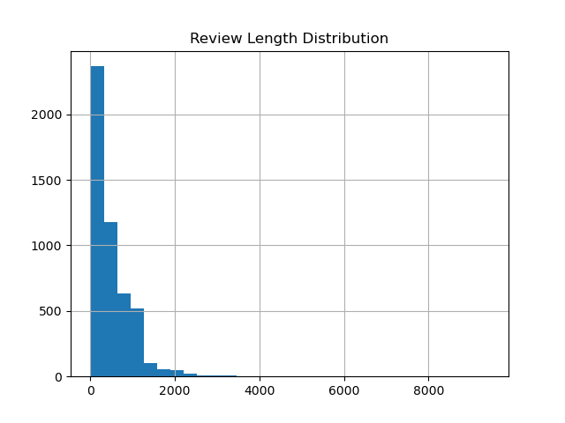
- Observation: The length of the cleaned reviews forms a somewhat normal distribution, with the majority of reviews being between 100 and 1,500 characters long.
- Interpretation: This indicates a good mix of short, concise complaints and longer, detailed narratives, providing rich data for both topic and sentiment analysis.

Feature Engineering & Selection

Creating Sentiment Labels
To train a supervised model, numeric ratings were mapped to categorical sentiment labels.
- Negative: Ratings 1-2
- Neutral: Rating 3
- Positive: Ratings 4-5
Distribution of Sentiment Labels
Negative | 2813
Positive | 2050
Neutral | 102

This confirmed the class imbalance problem, with very few "Neutral" reviews.

Text Preprocessing
The text data was unified and cleaned for both the Sentiment and Topic models.
- Combination: Review titles and content were concatenated to create a richer text field.
- Cleaning: A custom function was applied to:
  - Convert text to lowercase.
  - Remove all non-alphabetic characters (numbers, punctuation, symbols).
  - Remove extra whitespace.

Feature Extraction (TF-IDF)
The cleaned text was transformed into numerical features using a TfidfVectorizer with the following hyperparameters:
- max_features=5000: Limits the model to the most important 5,000 words to manage complexity.
- stop_words='english': Removes common, non-informative words (e.g., "the", "a", "is").
- ngram_range=(1,2): Captures both individual words and two-word phrases (e.g., "medical aid").

Model Training & Hyperparameters

Sentiment Analysis Model (Logistic Regression)
- Data Split: The dataset was split into 80% training and 20% testing sets using a stratified split to maintain the original class distribution.
- Model: LogisticRegression from sklearn.
- Hyperparameters:
  - max_iter=1000: Increased iterations to ensure convergence.
  - solver='lbfgs': A robust solver for large datasets.
  - class_weight='balanced': A critical setting to automatically adjust weights for the imbalanced 'Neutral' class, giving more importance to its correct classification.

Topic Modeling Model (LDA)
- Vectorizer: CountVectorizer was used (simpler than TF-IDF for LDA).
- Hyperparameters: max_features=3000, stop_words='english'.
- Model: LatentDirichletAllocation from sklearn.
- Hyperparameters: n_components=5 was chosen as a manageable number of broad topics to present to the client.

Model Evaluation & Interpretation

Sentiment Analysis Evaluation
Metric | Value
Accuracy | 94.2%
Macro Avg. F1-Score | 66%
Weighted Avg. F1-Score | 94%

Classification Report
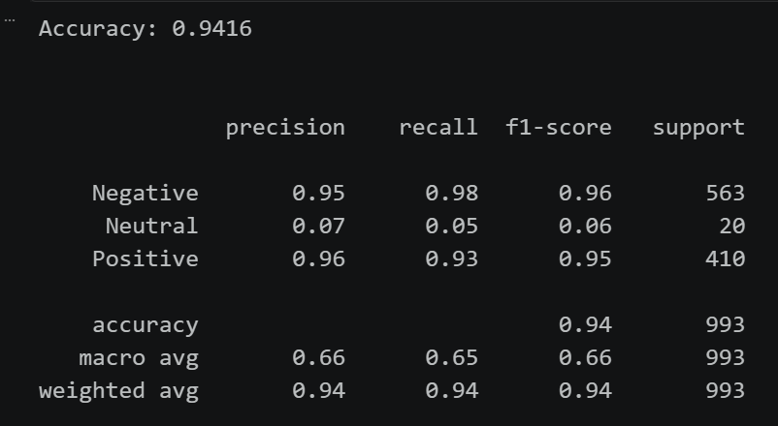
Confusion Matrix
Figure 4: Confusion Matrix
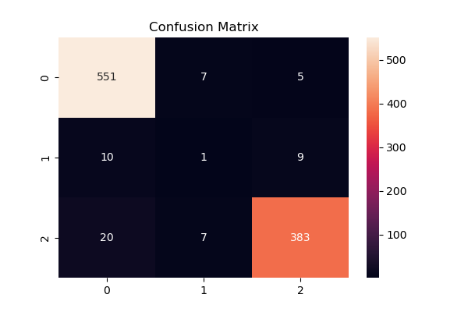
Interpretation:
- The model demonstrates excellent performance for Negative and Positive sentiments, as evidenced by high Precision, Recall, and F1-Scores.
- The overall Accuracy of 94.2% is very high, indicating that the model is correctly classifying the vast majority of reviews.
- The poor performance for the "Neutral" class is expected due to the severe class imbalance (only 102 neutral samples). The model learned to predict this class very rarely, leading to low recall and precision.
- Conclusion: The model is highly effective for distinguishing between primarily Negative and Positive feedback, which is the most critical need for the business.

Important Predictive Words
Examining the coefficients of the Logistic Regression model reveals what words were most influential in determining sentiment.
- Negative Sentiment: cover, useless, pathetic, money, worst, told.
  - Insight: Complaints often involve coverage (cover), value for money (money), and a general perception of incompetence (useless, worst). The word told suggests poor communication ("I was told...").
- Positive Sentiment: amazing, efficient, great, good, assisted, best, excellent, helpful, thank.
  - Insight: Positive reviews are characterized by praise for service (excellent, great), efficiency, and helpful staff (assisted, helpful).

Topic Modelling Findings
LDA was used to identify the main areas of concern present in the reviews.
Topic 1: affinity, health, medication, pharmacy, service, direct, dont, policy, money, chronic
Topic 2: bonitas, medical, aid, service, time, im, claim, dont, claims, just
Topic 3: hospital, pay, medical, bonitas, cover, doctor, claim, paid, aid, specialist
Topic 4: bonitas, br, email, received, account, sent, medical, payment, aid, paid
Topic 5: service, thank, great, excellent, affinity, good, helpful, health, friendly, customer
Interpretation of Topics:
- Topic 1 (Affinity Health - Core Concerns): This topic is heavily focused on chronic medication, pharmacy, and money. It suggests that customers are concerned about the management and coverage of their chronic medication through pharmacy services and feel they are not getting value for money.
- Topic 2 (Bonitas - Claims & Time): This topic centers on claims, waiting times, and general service. It indicates that Bonitas customers are experiencing delays and frustrations with the claims process.
- Topic 3 (Medical Services & Costs): This topic revolves around hospital care, doctors, and specialists. The presence of words like pay, cover, and claim suggests customers are worried about whether their medical expenses will be covered during hospital visits.
- Topic 4 (Communication & Payments): This topic is about communication (email, sent, received) and payments/accounts. It reveals that a significant area of friction is related to billing, account updates, and the correspondence around them, which may often be confusing or unresponsive.
- Topic 5 (Positive Experiences): This topic captures positive customer service interactions, highlighting words like great, excellent, helpful, and friendly. This is an encouraging finding, showing that while there are many complaints, there are also many instances of good service being delivered.

Retraining & Improvement Strategy
The current model is already performing very well for its primary task. However, given the poor performance on the "Neutral" class, a future retraining strategy could be implemented to improve its performance:
- Address Class Imbalance with "Neutral" Samples: The class_weight='balanced' parameter was a good first step. For a more robust solution, we could use more advanced techniques like SMOTE (Synthetic Minority Over-sampling Technique) to generate synthetic "Neutral" examples, or use an entirely different approach like BERT which has shown strong performance on imbalanced datasets.
- Refine Neutral Definition: The definition of a "Neutral" rating (rating=3) is quite strict. We could re-evaluate if rating=3 truly represents a "neutral" sentiment or if it's a "mildly negative" or "mixed" sentiment. A more nuanced labeling, perhaps using a 3-class system with a different threshold, might yield better results.

Business Recommendations
Based on the findings from our comprehensive text analysis, we propose the following strategic recommendations:
- Improve Chronic Medication and Pharmacy Services: The topic modeling reveals a strong, negative sentiment surrounding chronic medication and pharmacy services (Topic 1). The medical aid should:
  - Review Pharmacy Networks: Ensure that the pharmacy network provides convenient access and efficient service for chronic medication.
  - Simplify Re-Ordering: Streamline the process for patients to re-order their chronic medication, potentially via a dedicated, user-friendly app or portal.
  - Enhance Communication: Be proactive in communicating supply issues or delays to patients before they become a complaint.
- Streamline Claims and Pre-Authorization Processes: The combination of Topic 2 and Topic 3 points to significant friction in the claims and authorization process.
  - Reduce Waiting Times: Invest in technology and staff training to reduce the time taken to process claims and respond to pre-authorization requests.
  - Simplify Procedures: A common customer frustration is the complexity of the process. The goal should be a "one-click" or highly simplified digital experience.
  - Increase Transparency: Provide members with a simple, real-time tool to track the status of their claims.
- Enhance Customer Support Availability: The important words analysis highlighted "service" and "told" as key negative indicators, suggesting poor or unavailable support. The client should:
  - Extend Support Hours: As mentioned in one review, "customer service unavailability on weekends" is a critical pain point. Consider extending call center hours and providing robust online/chat support 24/7.
  - Improve First-Contact Resolution: Focus on empowering frontline staff to solve problems without multiple escalations or callbacks.
- Communicate Effectively and Proactively: Topic 4 highlights that miscommunication and billing errors are major drivers of dissatisfaction.
  - Clarify Billing & Payments: Ensure all billing statements, policy updates, and payment confirmations are clear and easy to understand.
  - Proactive Outreach: Move from reactive to proactive communication. Send status updates, reminders for important deadlines, and quick resolution confirmations to members.
- Celebrate and Replicate Positive Service: Topic 5 confirms that the company is capable of delivering excellent, helpful service. The client should:
  - Analyze "Positive" Reviews: Identify the specific teams or branches that consistently receive praise.
  - Reward Excellence: Implement recognition programs for staff who go above and beyond.
  - Standardize Best Practices: Use the patterns from positive reviews to create training materials and standard operating procedures that can be replicated across the organization.
By implementing these recommendations, the medical aid can directly address the most significant areas of customer pain, thereby reducing negative reviews, improving customer satisfaction, and strengthening their brand reputation.

